Reproductive Choices

1. Male Reproductive System
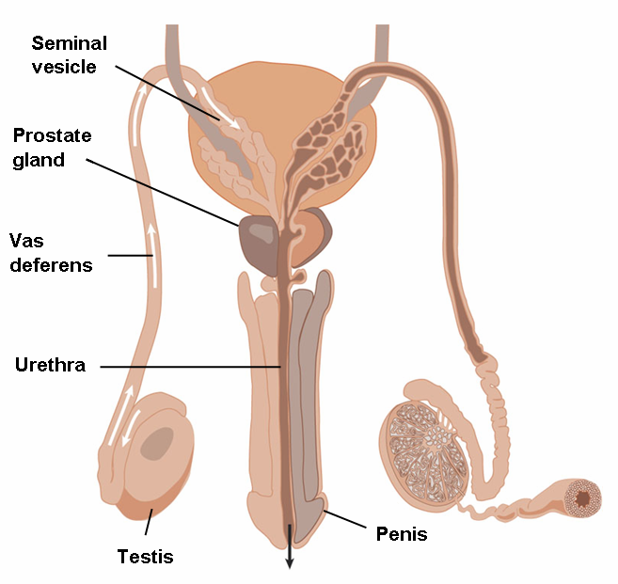

2. Female Reproductive System & Menstrual Cycle
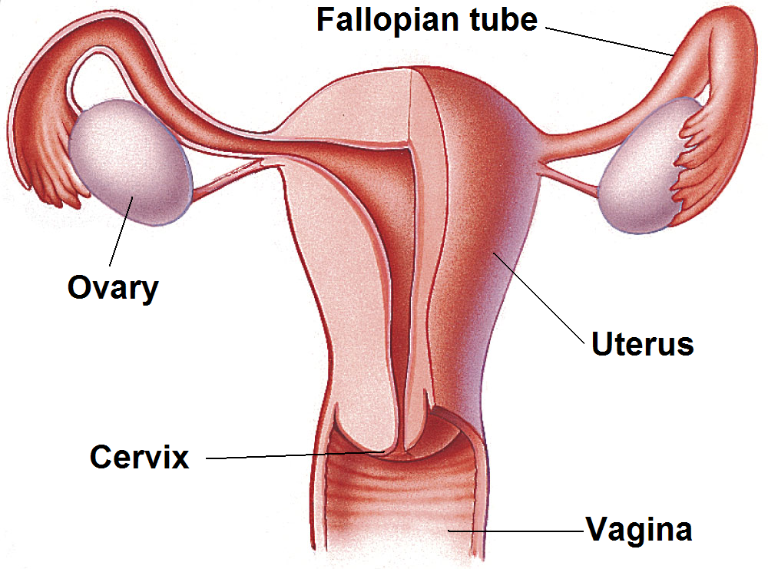
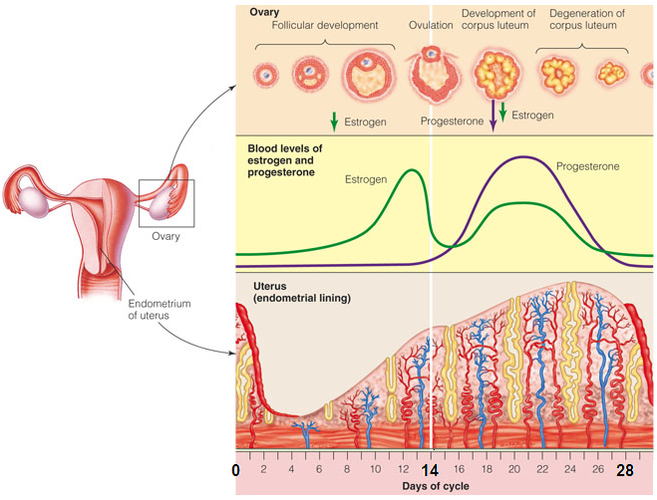
3. Conception

- Sex cell characteristics
- An (unfertilized) ovum can live up to 36 hours
- Ejaculate may contain up to 500 million sperm cells
- Sperm cells can survive in the ♀ tract for 5 days, sometimes more

- Sequence of events
- During intercourse: sperm cells are released in vagina
- Travel up → uterus → fallopian tubes
- If egg in the tube:
egg + 1 sperm can fuse: fertilization → zygote in fallopian tube
- Zygote travels down the fallopian tube while dividing
- In uterus: zygote burrows into the uterine wall: implantation

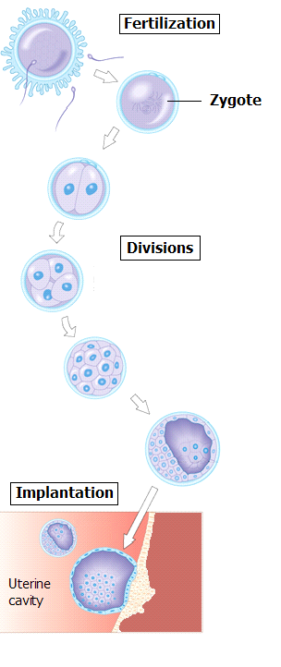

- Development of fertilized egg:
- Zygote → embryo (when nested in uterine wall) → fetus (after 9 w)
- Structures that support embryo/fetus during development:
.placenta: structure in uterus for exchange btw fetus/mother blood
.umbilical cord: connects fetus to placenta
.amnion: sac filled with amniotic fluid, that surrounds the fetus

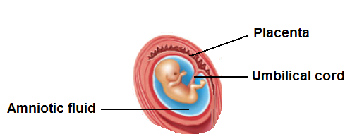

4. Birth Control Methods

- Can prevent
ovulation
meeting between egg & sperm
implantation

- Can be temporary or permanent

- Choice of method
- According to situation/beliefs/habits/risks…
- Some provide protection against STDs

Method | Mode of action | Advantages | Disadvantages
Abstinence  Outercourse | No sexual activity  No vaginal intercourse | No medical side effects | Risk of unplanned intercourse
Hormone-based contraceptives  Pills  contain estrogen and/or progestin  ingested daily  Implant  capsule under skin of upper arm  kept for at least 3 years  releases low & continuous progestin  Patch, injection, vaginal ring | Different mechanisms  inhibit ovulation  alter cervical mucus (thickens it)  alter uterus lining (→ no implantation) | Very effective  No interruption of sexual activity  Reduced menstrual cramps  More regular periods  ↓ risk of ovarian & uterine cancer  Highly effective  No interruption of sexual activity  No need to remember to use it  No estrogen-related side-effects | Requires prior medical examination & follow up  Has to be taken daily  Possible side effects (mostly due to estrogen):  ↑ risk of cardiovascular disease  (esp. if smokers, > 35 years, hypertension)  weight change, nausea, vomiting, mood changes…  Requires medical intervention  Possible side effects  menstrual irregularities, amenorrhea  ovarian cysts, breast discharge  headaches, acne, hair growth
Barrier contraceptives  ♂condom (latex or PU)  ♀ condom (PU)  Diaphragm & cervical cap  should be used with spermicides | Prevents egg & sperm meeting  Covers penis & catches the semen  Lines the walls of the vagina  Rubber cups that cover cervix  Kept for min 6 hours after intercourse | No prescription needed  No harmful side effects  Some protection from STDs  No harmful side effects  Placed prior to sexual experience | Interruption of sexual experience  May have defects, break or slip off  Sometimes allergy to latex  Need practice for correct use (for comfort/efficiency)  Sometimes allergy to latex
Spermicides  foams, creams, jellies, films… | Chemicals that kill sperm cells  Better if used with barrier contraceptives | No prescription needed  ↓ STDs (with barrier contraceptives) | Interruption of sexual experience  Skin irritation for some, messy
Intrauterine device (IUD)  T-shaped piece  inserted in uterus for many years | Interferes with implantation | Very effective  No interruption of sexual activity | Should be inserted by a physician  Risk of scarring & infertility  May be expelled
Sterilization  ♂: vasectomy  ♀: tubal ligation/occlusion | Cutting/tying vas deferens  Cutting/tying, blocking fallopian tubes | Highly effective  Permanent | Not easy to reverse for fertility  Surgical procedure → pain, bleeding, complications
Fertility awareness methods  Cervical mucus method  Calendar (rhythm) method  Basal body temperature | Intercourse during infertile days only  days of dryness or sticky mucus  days outside [shortest -18 / longest -11]  after 3 days of ↑ in body tº till cycle end | Acceptable to Catholic Church  No medical side effects  No expenses | Uncertainty of safe times  Periods of abstinence or use of other methods
Withdrawal  (Coitus interruptus) | Removal of penis from vagina before ejaculation | No medical side effects  No expenses | Interruption of intercourse  Not reliable: drops emitted before ejaculation  Difficulty to know when to withdraw

Emergency methods (after-intercourse)  Morning after pill (within 72 hours)  Abortion pill (within 9 weeks)  IUD insertion (within 5 days)  Menstrual extraction or curettage | High dose of oral contraceptives  Prevents ovulation or implantation  Blocks the action of progesterone  Prevents implantation  Suctions or scrapes out uterine content | Recommended in cases such as  rape  incest  broken or slipped off condom | Require medical supervision/intervention  Side effects: discomfort, cramps, infections…

Pills Implants
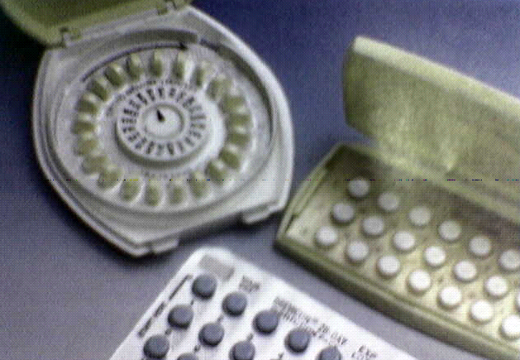

Male Codom Female Condom
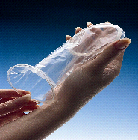

Cervical Cap / Diaphragm Vaginal Spermicides

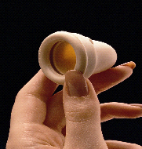
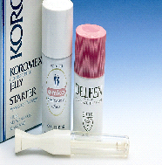

Intra Uterine Device Tubal Ligation
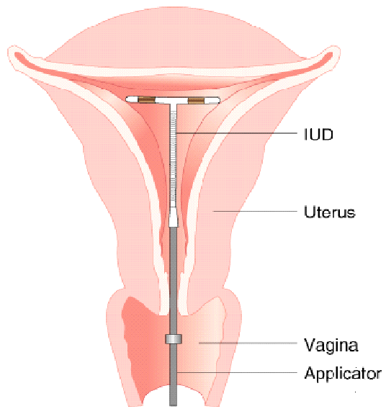
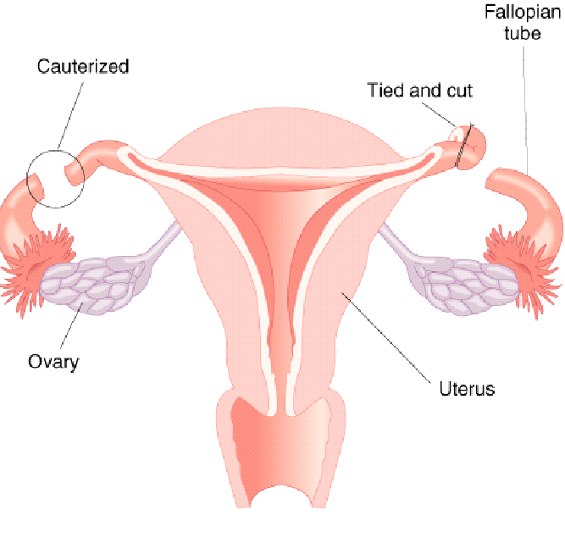

Fertility Awareness Method: basal body temperature
5. Pregnancy

- Preconception care
- Crucial for full-size, full-term, healthy infant
- Risks
smoking
drinking alcohol
using drugs
overweight/underweight
suffering from unrecognized infections and illnesses
exposure to environmental toxins

- Prenatal care

Nutrition
- Well-balanced diet throughout pregnancy (no dieting)
- Drinking plenty of fluids (water, fruit & vegetable juices, milk)
- Folate to ↓ risk of neural tube defects (abnormal spinal column)
- Appropriate weight gain, in relation with pre-pregnancy weight

Exercise
- Regular & moderate (walking, swimming…)
- Not pushing too hard (avoiding water-skiing, surfing, horse-riding)
- Stretching carefully because joints & connective tissue softer & looser
- Being aware of warning signs: faintness, dizziness, pain, bleeding

Substance use
- Smoking
active & passive smoking hazardous
increases risk of
miscarriage
premature birth, low birth weight, stillbirth
- Alcohol
effects proportional to dose
mild case: fetal alcohol effect (FAE)
impaired intellectual ability & school performance
severe case: fetal alcohol syndrome (FAS)
low birth weight & permanent mental impairment
- Drugs: increase risk of
malformations
premature birth
low birth weight, stillbirth

- Medications: necessity to consult a physician

- Caffeine: effects proportional to dose

Environmental risks
- Heat (hot tub, sauna, fever) in 1st trimester: ↑ risk of neural tube defects
- Radiation
high levels for cancer therapy linked to birth defects
X rays: avoid although not significant threat
- Fetus in theory vulnerable to pollutants, metals, toxins, gases, pesticides…
- Prenatal testing: for identification of defects

- Ultrasonography (no known risk)
use of sound waves to produce an image of the fetus on a video screen

- Amniocentesis (1% risk of miscarriage)
recommended if mother > 35 y, or known carrier of genetic disorder
removing some amniotic fluid (contains cells shed by the fetus)
culturing cells → checking for chromosomal defects

- Chorionic villi sampling (1% risk of miscarriage)
suctioning a small sample of fetal placental tissue
analysis for chromosomal defects
can be performed than amniocentesis

Complications
- Ectopic pregnancy: zygote remains in fallopian tube
possible causes: some STDs, use of IUD
symptoms include:bleeding, lower abdominal pain
treatment: surgical
can lead to permanent infertility (irreversible fallopian tube damage)

- Miscarriage: spontaneous abortion
emotionally devastating
causes: genetic, anatomic, hormonal, infectious, autoimmune

- Pregnancy and age:
Above 35: ↑ risk of birth defects due to chromosome abnormalities
(e.g. Down syndrome)

- Infections: major ones
Rubella
leads to birth defects
women should be vaccinated at least 3 months prior to conception
HIV
transmissible to baby during pregnancy, at birth or during lactation
Toxoplasmosis
transmitted by pets (cats) or by consumption of undercooked meat
effects on fetus: brain and retina damage, death

6. Infertility
- Failure to conceive after 1 year of unprotected intercourse in young couples

- Male
- Linked to sperm quality (inactive, misshapen) or quantity (< 20.10⁶/ml)
- Common causes
genetic
hormonal
blockage of a sperm duct
varicocele (enlarged vein → too much blood → testicle too warm)

- Female
- Common causes
age
genetic
hormonal
blocked fallopian tubes
immune reaction to a man’s sperm
uterine defects
cervical mucus problems
- Assisted reproductive technology

- Infertility treatments include
microsurgery (e.g. to open blocked ducts)
hormonal treatments

- Artificial insemination (when ♂ is infertile)
introduction of sperm (from sperm bank) into vagina by artificial means

- In vitro fertilization (e.g. when ♀ has damaged fallopian tubes)
removal of egg from ovary just before ovulation
egg and sperm placed in vial → fusion occurs in vitro
few division steps
embryos inserted in uterus → development continues
extra embryos can be frozen for later implantation

- Gestational surrogacy (when ♀ cannot maintain pregnancy)
embryo conceived in vitro
implanted in another ♀ uterus (hormonally treated → ready for gestation)

